GETLM Stencil of
[(-2,-1,0,1,3), (-2,-1,0,1,3)]
At the first time step
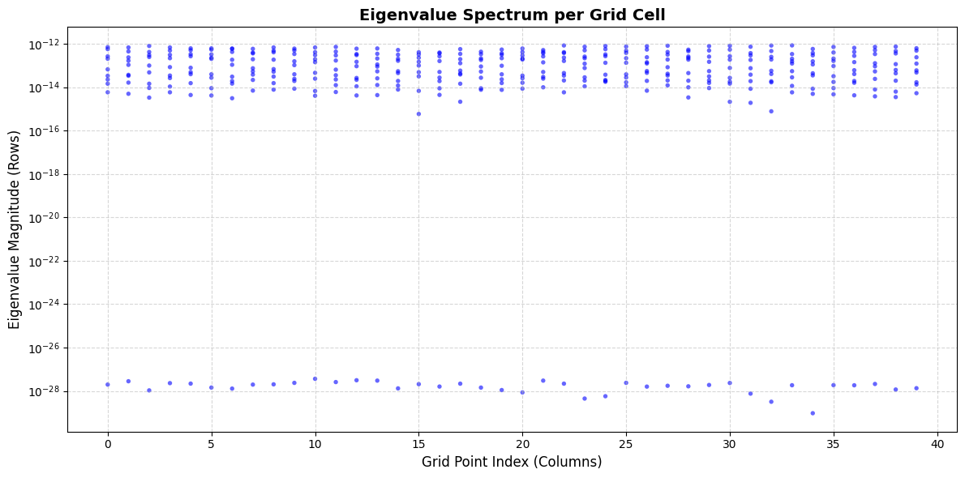
At the 10th time step
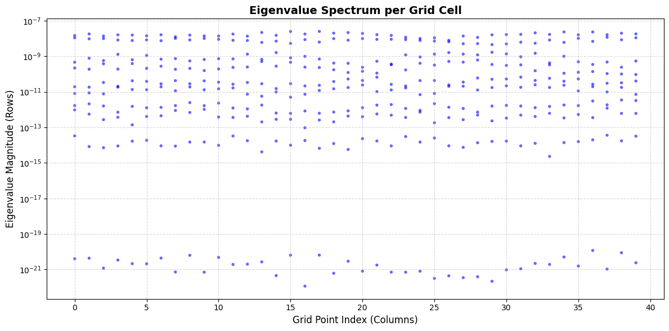

GETLM Stencil of
[(-2,-1,0,1,2,3), (-2,-1,0,1,2,3)]
After 1 time step
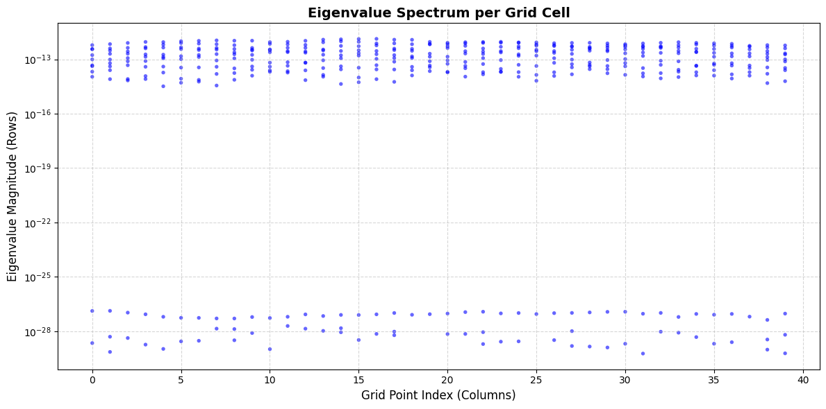
After 10 time steps
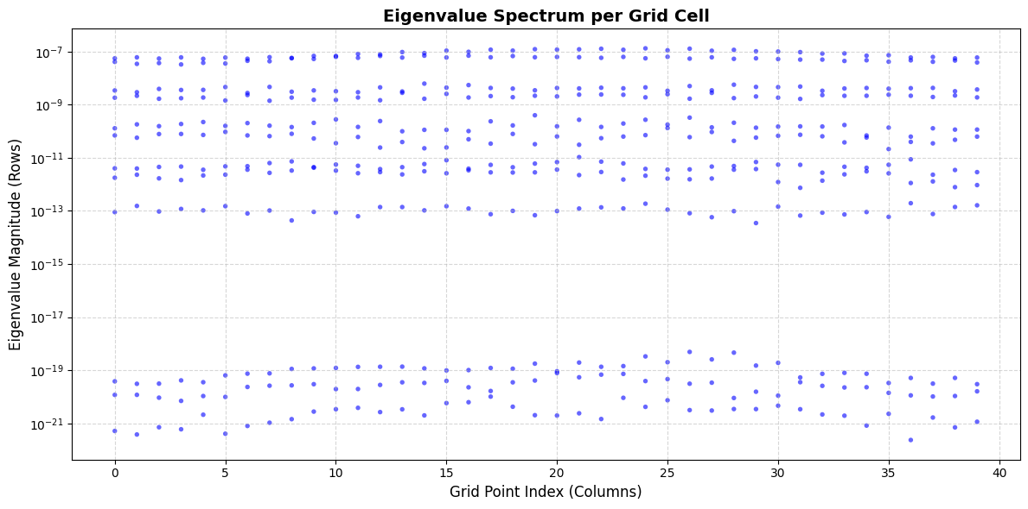

GETLM Stencil of
[(-2,-1,0,1,3,4), (-2,-1,0,1,3,4)]
After 1 time step

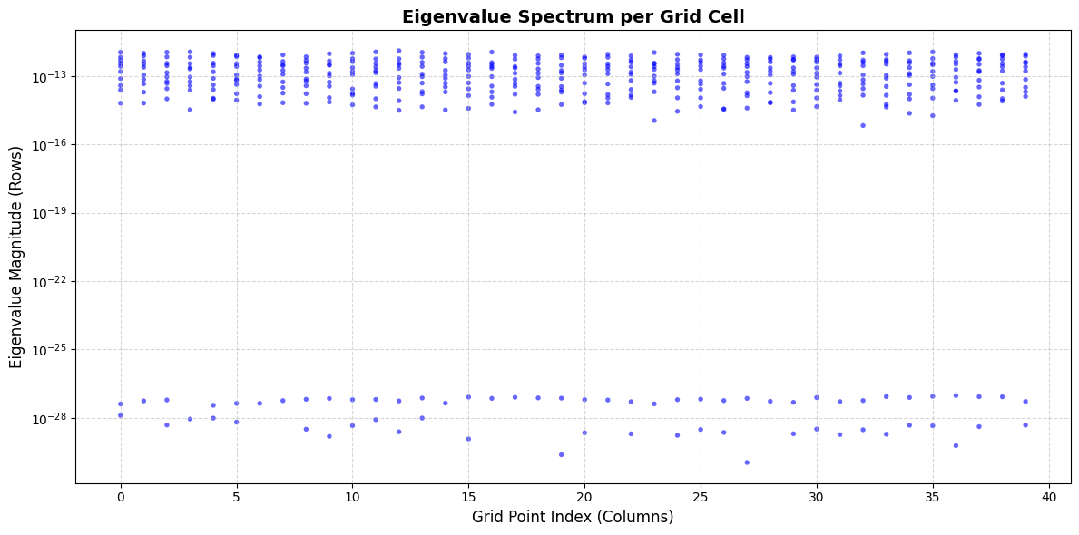
After 10 time steps
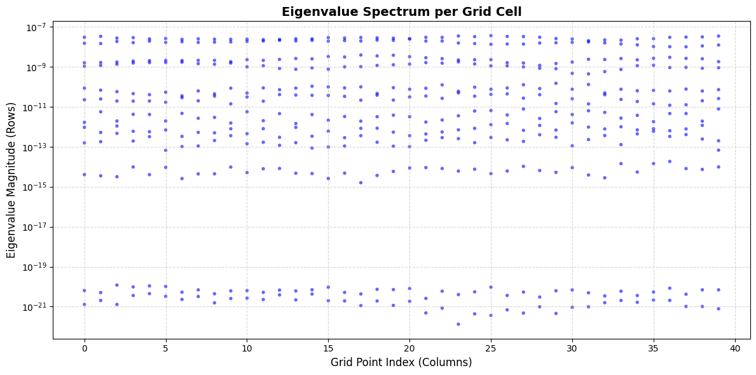

GETLM Stencil of
[[-5,-4,-3,-2,1,3,4,5], [-5,-4,-3,-2,1,3,4,5]]
After 1 time step
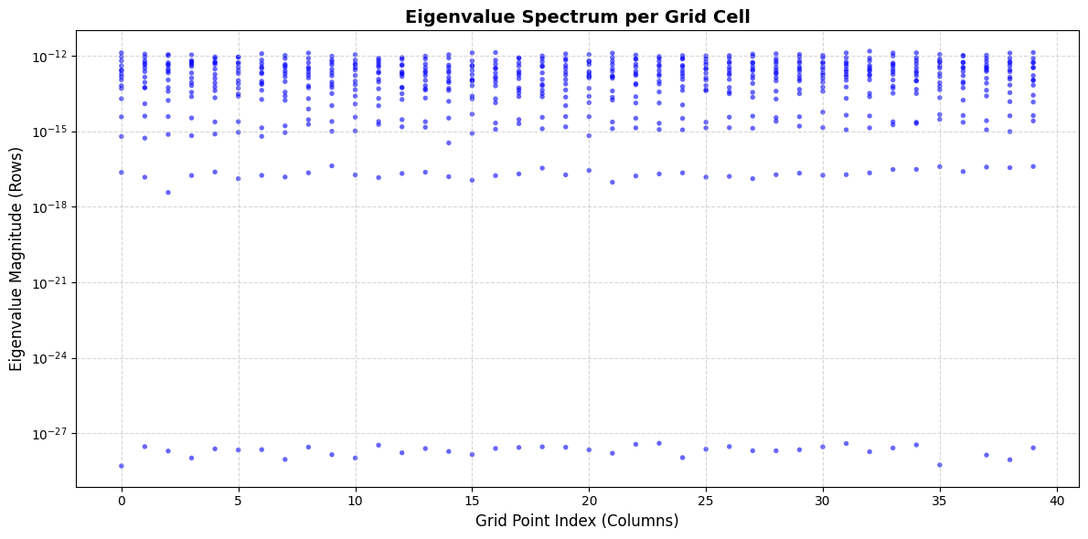
After ten time steps
